

Lost Payroll Check Affidavit

I am hereby requesting that UPMC stop payment on the following paycheck and issue me a replacement paycheck:

Check Number: 000000000518423 Check Date: _03/23/2018_____ Net Amount: $___8422.00____
Check Number: 000000000518422 Check Date: __03/23/2018____ Net Amount: $__2018.33_____

I am unable to cash the original check because it was:

__X_____ Lost ______ Stolen ______ Destroyed _____ Damaged _____ Other

Explain: I have added my account and routing number of my bank for direct deposit from the portal. But, never received my pay.

I hereby verify that the paycheck described above has not been endorsed or cashed by me or by anyone known to me. ___AS________
I agree that if the original check is delivered or returned to me, I will immediately return it to Corporate Payroll and will not attempt to cash it. ____AS______
I understand that if I cash, or attempt to cash, the original check either before or after requesting a stop payment or after receiving a replacement check, I will be terminated from my employment and criminal charges will be brought against me. __AS________
I understand and agree that if the original check is cashed, UPMC will take appropriate action to collect the amount including deducting the net amount from any monies owed to me by UPMC, and I hereby authorize such deduction. ___AS______
I understand the earliest a replacement check will be issued will be the Tuesday following the date of the paycheck that was not received. ___AS_________
I further affirm that if I become aware of any other person cashing or attempting to cash the check described above, I will immediately report that information to UPMC and will cooperate in any investigation or prosecution as requested by UPMC. ___AS________

It is my intention to be legally bound by this agreement. ___AS_____

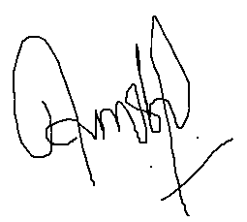
_________________________________________ _03/29/2018______________________
Employee Signature Date Signed

__AMRITA SHRESTHA______________________ ____00216989_____________________
Employee Name (please print) Employee ID
* Paycheck will be mailed to home address.

UPMC Corporate Payroll ● 600 Grant Street - Floor 56● Pittsburgh PA 15219
Telephone: (412) 647-3297 ● Fax: (412) 647-8616

